Companies_ FEIN field validation-does not return error

Steps:

1. Navigate to TF New Arch > Companies

2. Click on + to create a new company

3. Create a company with a 6 digit FEIN

4. Click on Save and validate.

5. Return to the grid to validate if the newly created company displays

6. Compare with TF 11

Actual Results:

In TF New Arch, returns the msg. Saved Successfully (FAIL)

On returning to the grid does not display the newly created.

In TF 11, FEIN field validation is performed and digits returns an error msg “FEIN is a 9 digit numeric field.”

Expected Results:

TF New Arch and in TF 11 functions should be identical.

Field validation of FEIN should be performed.

Create a company with 6 digit FEIN

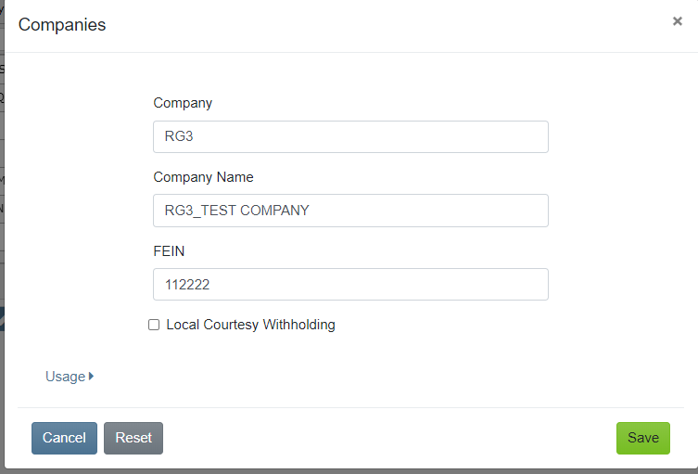

Returns the msg Saved successfully

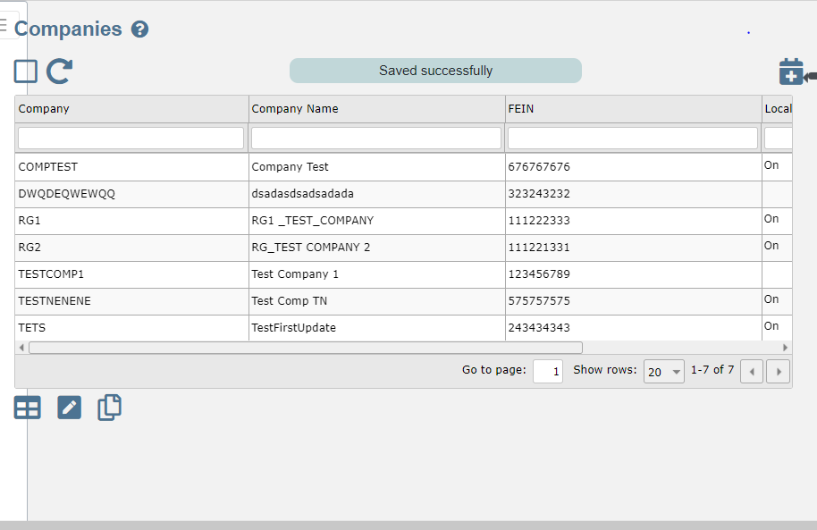

On refreshing does not display the company with 6 digit FEIN

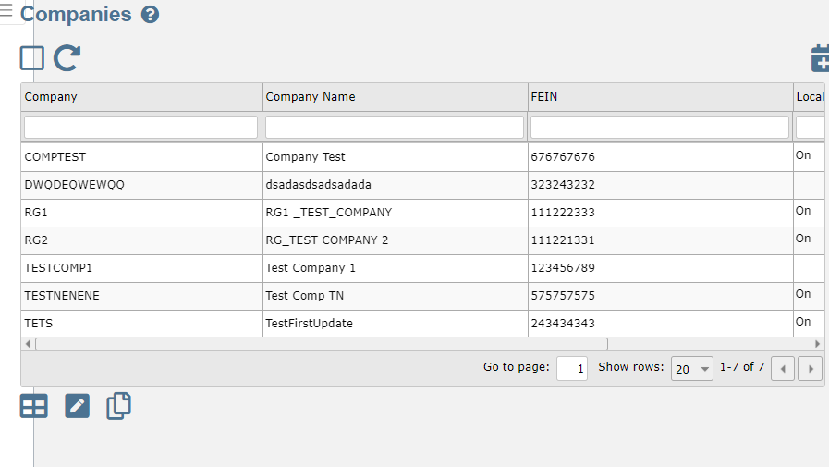

In TF 11 returns error msg

